Home Section

The colour contrast between the white text and the “Meet the Enpower Community!” button is low. The contrast ratio is 2.67:1 which fail the 1.4.2 level. Change the colour of the button. The recommended color change is #a55f37 for the button.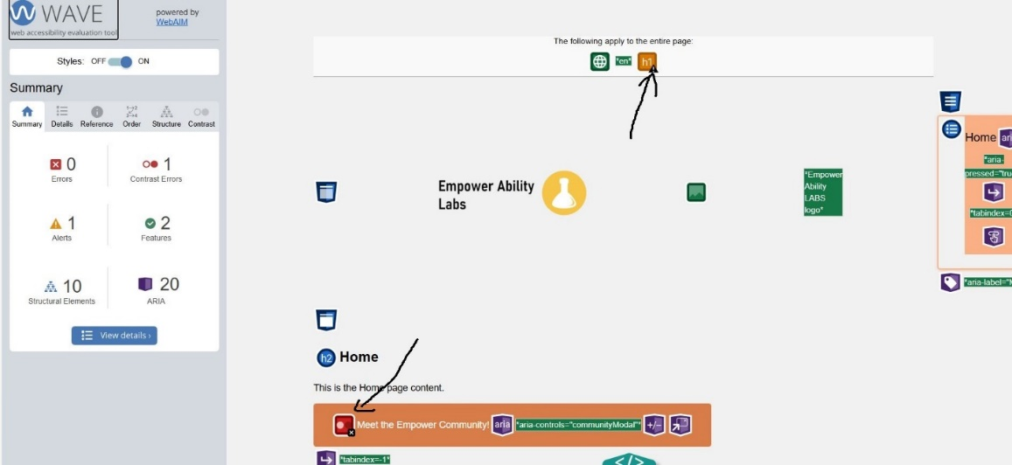

The page has no first level heading. Please put a heading at the top.

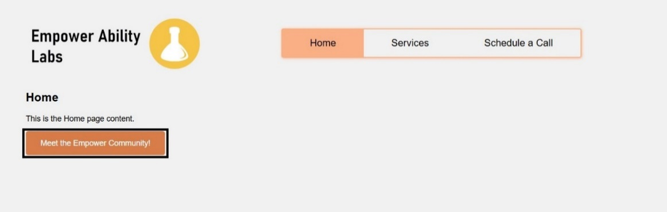

“What tools do they employ?” sentence has been miss by the screen reader

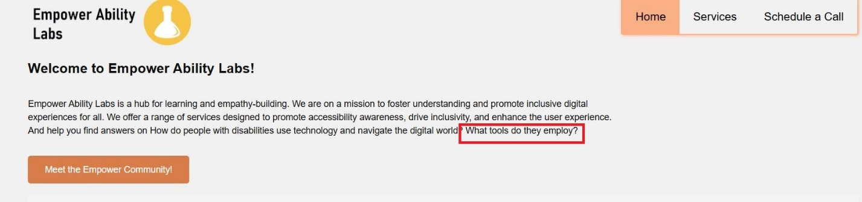

Services

There is no alt text or aria values in the image in the Services section.

Schedule A Call

Again, there is no alt text or aria values in the image in the Schedule a Call section.

Again, the button has a low colour contrast. Change the color of the button.



The aria-label in the link below the Services section in the table is the same as the aria-label in the button

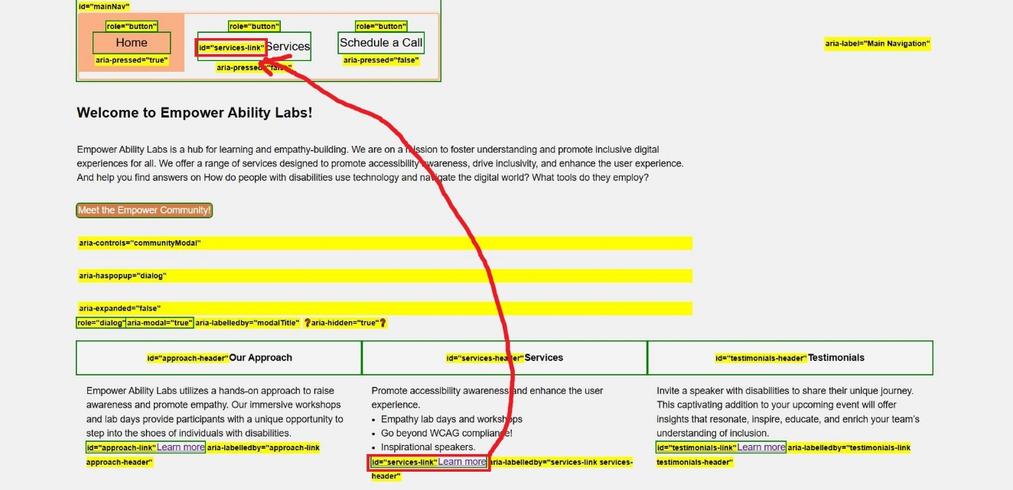

The toggle switch image is not found

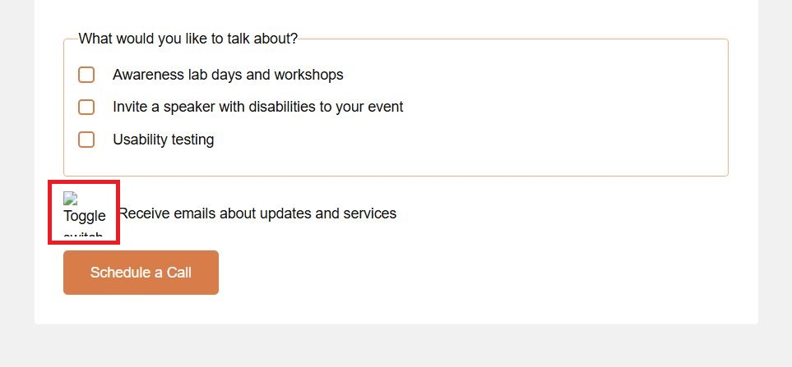

Saying random stuff.

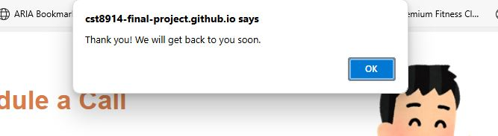

Saying random stuff after selecting “Ok”

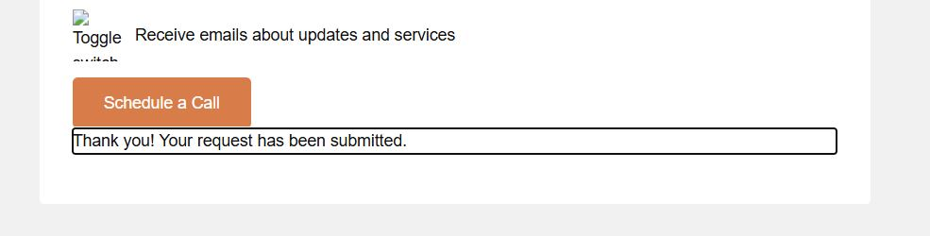

Cannot navigate though the checkboxes though the arrows keys.

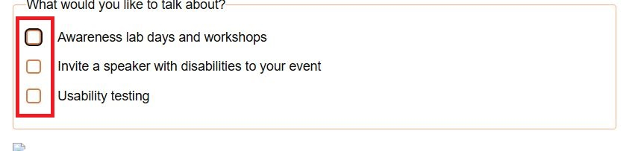

The links in the table does not tell us where the link goes to.

